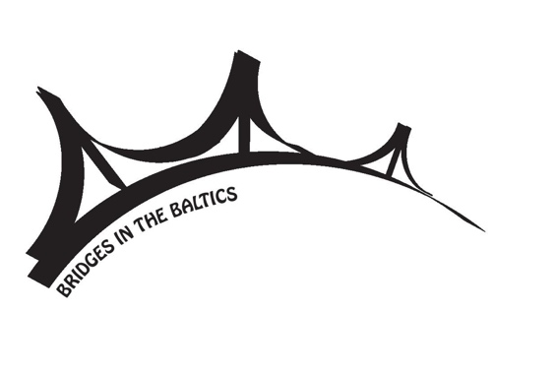
The 8th Baltic Student Conference
“Bridges in the Baltics”
October 16–17, 2020, Vilnius

Name, surname
University, city, country
Academic level
E-mail address
Phone number
Research field
Title of presentation
Language of presentation
Abstract
(not exceeding 200 words without references)

