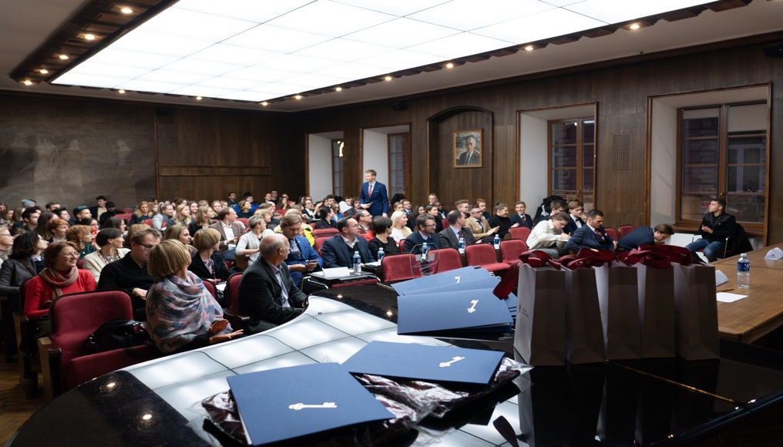Applied DEBATE 2022 “Leadership in times of crisis”  december 15, 18:00  Motion 1: THB that showing true compassion is easier said than done for leadership in times of crisis.  GOV Creative Communication 1  OPP Philosophy  Motion 2: THB that spending too much time on the problem can lead to Hamlet’s trap.  GOV Journalism  OPP Politics 3  Motion 3: THB that transparency should be excluded from leadership in times of crisis.  GOV Politics 1  OPP Economics and Business Administration  Motion 4: THB that admitting mistakes in times of crisis can be counter-productive.  GOV Creative Communication 2  OPP Asian and Transcultural Studies  Motion 5: THB that innovation is a key to abandoning non-productive strategies in times of crisis.  GOV Genetics  OPP Politics 2  “We cannot live better than in seeking to become better.”  ― Socrates | 10 teams  ────  5  adjudicators Leaders that inspire!  Dr. Loreta Skurvydaitė Emily J. Hicks  Dr. Karolis Ažukaitis  Dr. Živilė Skibarkienė  Mark Pass  Venue  Vilnius University Faculty of Philology  Universiteto g. 5  V. Krėvės room

