International Student Conference
English Studies 2026: Discourse and Society

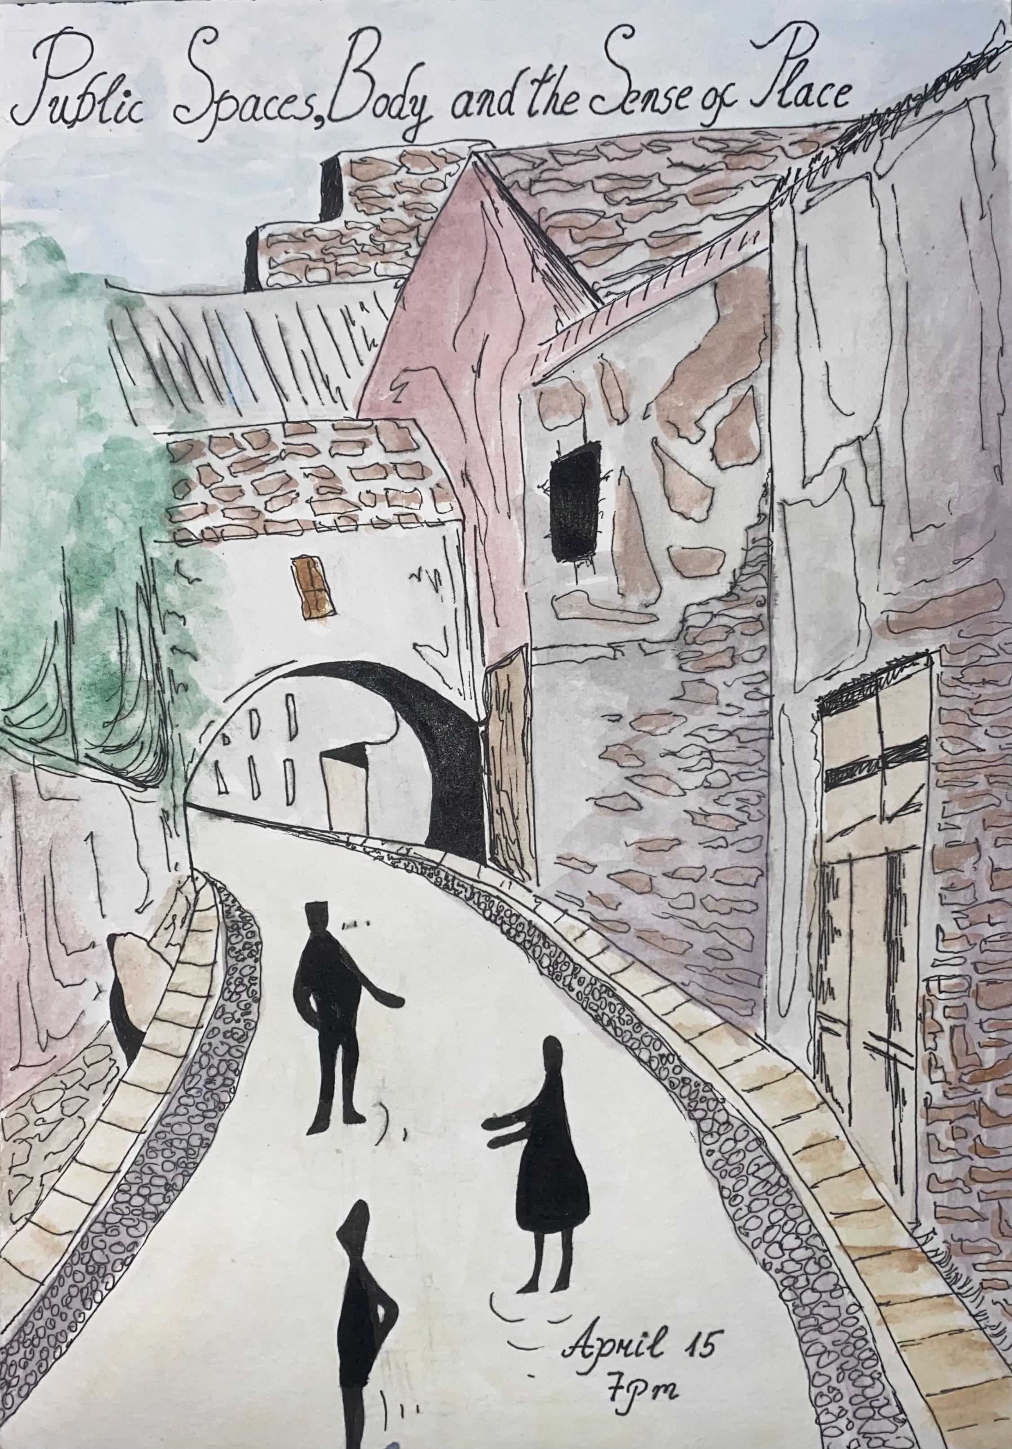
April 15 (Wednesday) 19:00-21:00 pre-conference get-together walk
“Public Spaces, Body and the Sense of Place” in the Old Town with Prof. Dr Almantas Samalavičius
As part of an MA course “Brick, Stone, Water: The Body and The City”.
We meet near the Vilnius Town Hall (Vilniaus Rotušė) at 19:00. 🌿
April 16 (Thursday) 🌿
9:00 – 9:40 Registration
9:45 –10:00 Welcome (Krėvės Room)
10:00 – 10:40 Plenary Talk (Krėvės Room)
Francisco Martin Miguel, From Words to Worlds: Language, Identity and Emotion
English Studies - Keynote speakers
Moderator Assoc. Prof. Dr Giedrė Balčytytė
10:50- 11:30 Plenary Talk (Krėvės Room)
Kaidi Lõo, Introducing EALD: what 500 Estonian listeners can tell us about spoken word recognition
English Studies - Keynote speakers
Moderator Assoc. Prof. Dr Laura Vilkaitė Lozdienė
Tea/ Coffee: 11: 30– 12.00 (Rašytojų menė) 🌿
Section 1  Room A 7 (Canada)  Moderator Saulė Alminaitė | Section 2  Room A 8 (Rachilės Aprijaskytės)  Moderator Lara Su Yaman | Section 3  (Room A 9)  Moderator Fausta Bauer | Section 4  (Room 122)  Moderator Assoc. Prof. Dr Liudmila Arcimavičienė
12:00 –12:20  Letizia Pagani, Social and Narrative Constraints Surrounding Sexual Violence in Ian McEwan’s Atonement | 12:00 –12:20  Agnė Semėnaitė, Figuring (Out) Abjection in Charlotte Wood's The Natural Way of Things | 12:00 –12:20  Nurassyl Silan,  A Corpus-Driven Study of Lexis in EFL Graded Readers in Kazakhstan | 12:00 –12:20  Dovydas Žemaitaitis,  In-Group, Out-Group and the Nation: Populist Framing of Climate Change in Trump and Bolsonaro’s Speeches
12:20 –12:45  Olga Donskaia  Between Propaganda and Indoctrination: Thoughtlessness in Margaret Atwood’s The Handmaid’s Tale | 12:20 –12:45  Emilija Varnelytė, Against Normativity: Queer Bildungsroman in Eileen Myles’ Cool for You | 12:20 –12:45  Mohamed Takouti,  The Effect of Differentiated Assessment on Students’ Grades and Attitudes toward Testing: 9th-grade students of Jnan Daroua Middle School as a case study. | 12:20 –12:45  Iryna Neschotna and Yejin Kim, Identity and Belonging: A Narrative Inquiry Study of a Chinese International Student in Australia
12:45 –13:05  Emilija Lipskytė  “But Now We Have to Prove the Connection Between the Man and the Beast”: The Relationship between Stapleton and the Hound in Sir Arthur Conan Doyle’s The Hound of the Baskervilles | 12:45 –13:05  Emilija Palionytė,  Showing the Unspoken: Adapting Interiority and Neurotic Conflict in Claire Keegan’s Small Things Like These | 12:45 –13:05  Yulia Shcherbino,  Emotional Engagement in Reading Fiction Texts by L1 and L2 Speakers | 12:45 –13:05  Gabija Masiulytė,  Discursive Identification of Small-Island Nations in Climate Diplomacy: from Victimhood to Agency
13:05 –13:25  Sofiia Kalenska,  Motherhood in Paul Lynch’s Prophet Song | 13:05 –13:25  Maria Dreer,  Staging Resilience and Collapse: Gender and Mise-en-scène in David Fincher’s Fight Club | 13:05 –13:25 (online)  Anara Ashimova,  The Effectiveness of Using Documentary Films for Developing Communicative Competence in English Language Lessons | 13:05 –13:25  (online)  Shugyla Kudaibergen,  How TV Shows Teach Us to Communicate: A Discourse Analysis of Character Interactions in Popular Youth Series
Lunch 13.25- 14:25 🌿
Workshop 1 (14:25- 15:25) (Room A 7 Canada)  Orlagh Woods, Reproductive Bodies, Radical Texts  English Studies - Keynote speakers  Moderator Rūta Kružikaitė |  | Workshop 2 (14:25-15:25) (Room A9) Moderator  Silvia Peterssen, Social actors in news reports on abortion: how to analyse them and why they matter. English Studies - Keynote speakers  Moderator Assoc. Prof. Dr Liudmila Arcimavičienė
Workshop 3 (14:25 – 15:25) (Room A 8)  Lilija Rakova, Inner Universe into Verse  English Studies - Keynote speakers  Moderator Emilija Lipskytė |  | Workshop 4 (14:25 – 15:25) (Room 122)  Davide Castiglione, A collective stylistic analysis? Yes, please! English Studies - Keynote speakers  Moderator Assoc. Prof. Dr Jurga Cibulskienė
Tea/ Coffee 15:25 – 15:50 (Rašytojų menė) 🌿
Section 1 (Room A 7 (Canada) Moderator  Lara Su Yaman | Section 2 (Room A 8 (Rachilės Aprijaskytės)  Moderator Assoc. Prof. Dr Giedrė Balčytytė | Section 3 (Room A 9)  Moderator Assoc. Prof. Dr Anna Ruskan | Section 4 (Room 122) Moderator Dr. Jelena Kirejeva
15:50 –16:10  Patricija Kamarauskaitė, Fragile Worlds, Fragmented Narratives: A Possible Worlds Analysis of “Slay the Princess” | 15:50 –16:10  Ugnė Guzevičiūtė,  Metaphorical Framing of Political Figures in Online Discourse: Reactions to Charlie Kirk's Death | 15:50 –16:10  Khaled Ahmed, Diachronic Change in Stance Adverbials in British English Academic Prose: Evidence from BNC 1994 and BNC 2014 | 15:50 –16:10  Artūr Afanasjev,  Translation of Slang and Informal Language in the Call of Duty Video Game: Challenges and Solutions for Russian Localization
16:10 –16:30  Fausta Bauer, “Outside, there is London”: Queer Precarity and Urban Space in Oisín McKenna’s Evenings and Weekends | 16:10 –16:30  Tautė Martinaitytė,  Zooming in on the evaluative metaphor in film reviews | 16:10 –16:30  Greta Bučaitė,  Stance as a Device of Characterization in Telecinematic  Discourse: The Case Study of the Female Ensemble in Sex and the City | 16:10 –16:30  Lalazar Nazarova  Attentional Interference of Native vs. Borrowed Profanity: An Emotional Stroop Study of Lithuanian and Russian Curse Words
16:30 –16:50  Aistė Nadolskytė,  “What is Given May Be Taken Away”: Coping with Grief in Maggie O’Farrell’s Hamnet | 16:30 –16:50  Adriana Šulcaitė,  J. Biden’s and D. Trump’s approach to the Russia-Ukraine war through figurative language | 16:30 –16:50 (online)  Aisulu Kospanova,  The Impact of Identity, Context, and Motivation on Code-Switching Among Bilingual Students | 16:30 –16:50  Jamila Manafli, English as a 'Third Space' in Post-Soviet Language Politics: Insights from Azerbaijan
16:50 –17:10  (online)  Irmak Soran,  Fashioning the Monstrous Feminine: Myth, Power, and Cultural Re-Signification | 16:50 –17:10 (online)  Dilnaz Begalina,  How short-form social media discourse shapes students’ perceptions of social issues: a critical discourse analysis |  | 16:50 –17:10 (online)  Yerassyl Kaip,  Negotiating Identity in Online Fan Communities: A Multimodal Discourse Analysis
Student Conference Social on Campus: 18:00 – 20:00 Rašytojų menė 🌿
Certificates of Attendance will be awarded at the end of Day 1 to participants who present on Day 1.

April 17 (Friday)
Registration Day 2. Coffee/Tea 10.15 - 11:00🌿
11:00 – 11:40 Plenary Talk (Krėvės Room)
Jan Borm, Greenland Under Feminine Eyes: Three Anglophone Women Travellers of the 20th and 21st century. English Studies - Keynote speakers
Moderator Dr. Linara Bartkuvienė

11:40 – 12:15
Regina Rudaitytė, The World as a Structured Play of Shapes, Forms and Colours.
English Studies - Keynote speakers
Moderator Dr. Linara Bartkuvienė

Lunch/ Tea/ Coffee 12:15 – 12:40 (Rašytojų menė) 🌿
Section 1 (Room 122) Moderator Rūta Kružikaitė | Section 2 (Room 113)  Moderator Assoc. Prof. Dr Jurga Cibulskienė | Section 4 (Room 121)  Moderator Prof. Dr Jolanta Šinkūnienė
12:40 –13:00  Agnes Tarnoki, The Noble Pursuit of Knowledge: A Critical Analysis of Elitism and Exclusion in Dark Academia Literature and Beyond | 12:40 –13:00  Eva Vitkovskaja,  Fast Cars, Sharp Tongues: Prosodic Markers of Sarcasm in Formula 1 Drivers' Speech | 12:40 –13:00  Viktorija Timpaitė,  Proper Names in Children's Literature and Their Translation
13:00 –13:20  Lara Su Yaman,  A Double Panopticon: The Narrator of Charlotte Perkins Gilman’s “The Yellow Wallpaper” as Prisoner and Observer | 13:00 –13:20  Greta Pakalkaitė,  Monochronic Meets Polychronic: A Cross-Cultural Chronemic Analysis in Lithuanian-Chilean Interaction | 13:00 –13:20  Viltė Šiupinytė,  How Idioms Survive in Translation: Analysis of the novel and film Where the Crawdads Sing
13:20 –13:40 (online)  Arčis Auštras, Metafiction in David Foster Wallace’s “Good Old Neon” | 13:20 –13:40  Saulė Aleknavčiūtė  The Formation of English Neologisms on Reddit and X Platforms | 13:20 –13:40  Ovidijus Videika  Hate Speech on Social Media: Anti-LGBTQ+ Rhetoric in Comments on Fox News Facebook Posts
13:40 –14:00 (online)  Bibinur Nurlan,  Narrative Discourse and the Construction of Hero Identity in Percy Jackson and the Lightning Thief | 13:40 –14:00 (online)  Anzhani Nurgaliyeva, Neologisms in social media discourse and their influence on contemporary English
14:30 – 15:00 Awards, Farewell (Room Krėvės) Certificates of Attendance will be awarded at the end of Day 2 to participants who present on Day 2.

