The Mind Of A Journalist
A Meeting with Rūta Kupetytė

by Iveta Danieliciute

On November 26, 2018, Rūta Kupetytė visited first year journalism students of Vilnius University. She shared her story of finding the path to journalism and gave some advice.
​
Kupetytė has been working at LRT radio for almost eight years. This woman now hosts two radio shows: “Morning Sounds” and “10–12”. She revealed that radio shows can be broadcast not only from the studio but also from other places if the special equipment is available. Then she showed some technological tools that journalists use.
Kupetytė talked about skills that are crucial for journalists, and one of them is knowing the English language. Kupetytė gave examples such as Lithuanian journalists often having to go to EU institutions and attend EU conferences. Those who work in the newspapers’ editorial offices might translate information obtained from foreign sources. Interviewed people can also be non-native, so knowing as many foreign languages as possible is an advantageous skill for journalists. Another thing that should be remembered is that journalists can never talk aggressively, but sometimes a little pressure is needed to get the information.
Touching on a painful topic, Kupetytė mentioned that she, like the majority of all people, didn’t like her voice, but she soothed the students by pointing out that everything is changeable and one’s voice is not an exception. Journalists learn how to breathe and talk in a different way than people usually do, so their voices get lower and become more suitable for broadcasting on radio or television. She paid attention, however, to the fact that the mind, not the voice, is the most significant thing, meaning that journalists’ thoughts and questions must be interesting and catchy.
When I asked her about the possibility for journalism students to get an internship LRT, Kupetytė said, “Yes, of course. LRT accepts students with pleasure. Some of them even get a job and stay there, like me,” This answer is motivating to aim for higher goals for many students of Vilnius University.
Despite the fact that Kupetytė studied both journalism and political studies, she is satisfied with her current job. We are glad for her and wish her the best of luck!

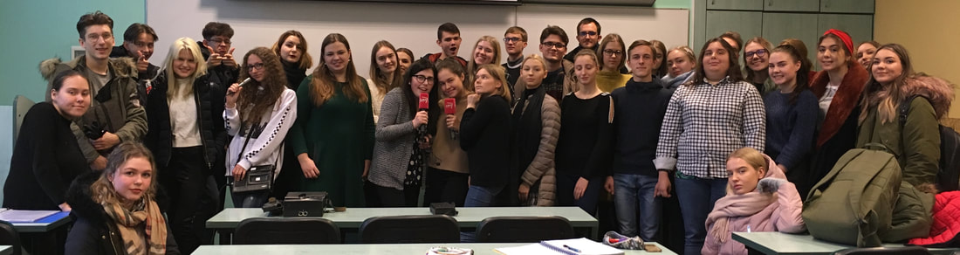
Photograph by Jeff La Roux

